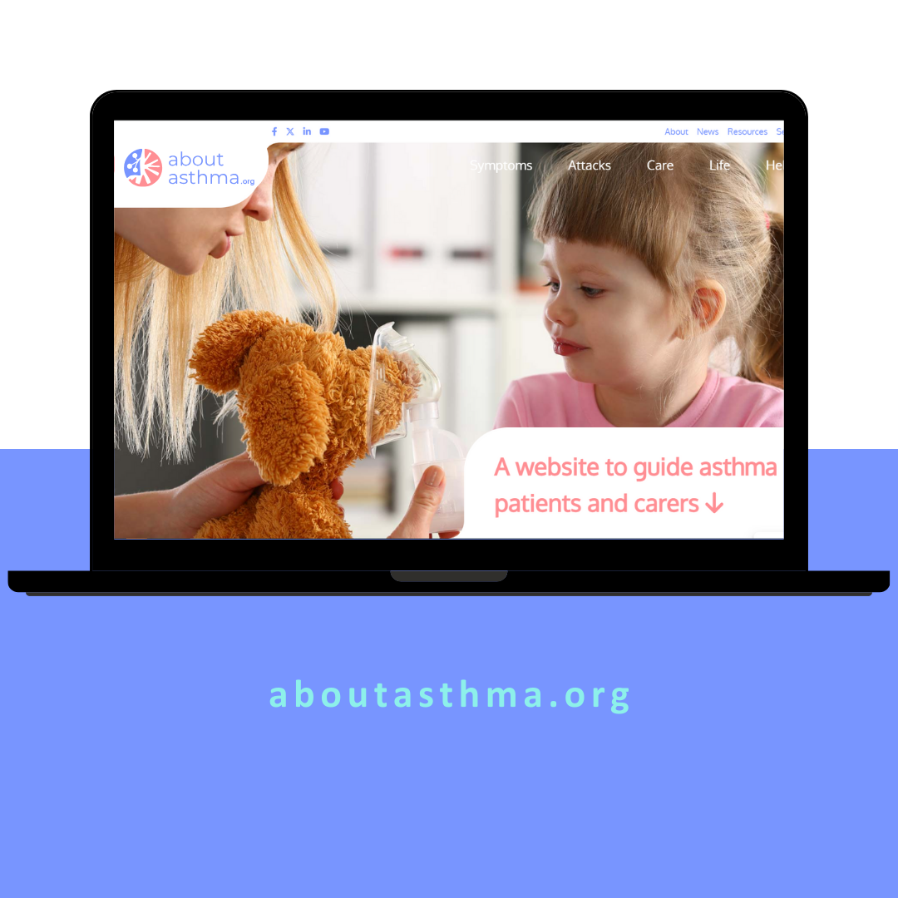
AboutAsthma.org
A website to guide asthma patients and carers
Contents
AboutAsthma.org 3
Promotional Toolkit 3
Materials for download 4
aboutasthma.org: overview of the website 5
Social Media Posts 8
Website, Direct E-mail & / or Newsletter Announcement 15
Additional Recommendations to support aboutasthma.org 16

For questions regarding aboutasthma.org or this toolkit, please get in touch with:
Isabel Proaño Gómez
Deputy Director | Director of Policy and Communications
EFA - European Federation of Allergy and Airways Diseases Patients' Associations
isabel.proano@efanet.org | Tel.: +32 (0)2 227 2712

AboutAsthma.org

Promotional Toolkit

We are delighted to present to you the Promotional Toolkit for aboutasthma.org, an innovative initiative developed by the European Federation of Allergy and Airways Diseases Patients’ Associations (EFA), aimed to empowering individuals living with asthma and their caregivers.
This comprehensive toolkit offers a range of promotional materials carefully crafted to facilitate the spread of awareness about aboutasthma.org and foster engagement within the asthma community.
Together, we can collectively enhance support and resources for individuals affected by asthma. Your involvement can make a significant difference in raising awareness and accessibility for information around asthma management. Let's work together to ensure everyone has the knowledge and tools they need to lead healthier lives.
Contained within this toolkit are the following resources:
- Logo: The official logo of aboutasthma.org, available for display on your website or other promotional materials.
- Website banner: A visually appealing banner ready for upload to your website, aiding in the dissemination of information about aboutasthma.org.
- Factsheet: A succinct overview of aboutasthma.org, highlighting its content and key features that you can share with your network via digital channels, upload to your website or print it out as a leave-behind.
- Aboutasthma.org website overview: Explore the purpose and components of the aboutasthma.org platform.
- Press Release: A professionally crafted press release announcing the launch of aboutasthma.org, providing journalists with compelling information to cover the story.
- Social Media Posts: Pre-written messages accompanied by hashtags and visuals, perfect for sharing on social media platforms to expand the reach of aboutasthma.org and #aboutasthma.
- Announcement for Newsletter, Direct e-mail and /or website: A concise message tailored for inclusion in newsletters, email campaigns, and websites, informing your audience about aboutasthma.org and encouraging their support.
- Additional Recommendations: Supplementary suggestions to enhance your promotional efforts and maximize the impact of aboutasthma.org in your community.
We trust that these resources will prove invaluable in promoting aboutasthma.org and driving positive change for individuals affected by asthma.
Thank you for your commitment to this important cause, and we look forward to collaborating with you!

Visual Materials
Download here
Download the below assets for easier use in your communications and promotion efforts
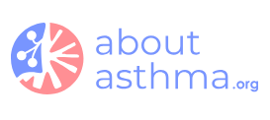
aboutasthma.org Logo

Share the spirit of aboutasthma.org with your community! Add a link to aboutasthma.org website and materials to your own website.

Visuals (EN, IT, FR, ES)
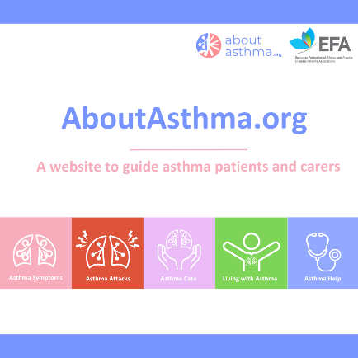
Recommended use: Boost awareness in your community with our website banner! Simply upload it to your site and help spread the word about aboutasthma.org. (Don't forget to add a link to download the image!)

Factsheet aboutasthma.org (EN)
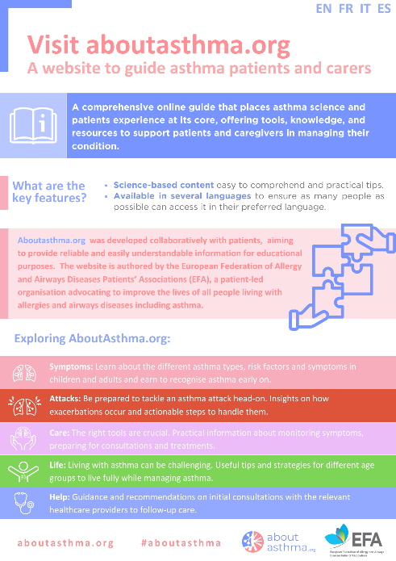
Recommended use: Spread the word about aboutasthma.org, with this factsheet for patients. It offers a concise snapshot of this educational tool, its valuable content and key features. Share it with your network through digital channels, upload it to your website or print it out as a handy leave-behind.

aboutasthma.org: overview of the website
Discover the heart of aboutashma.org! This overview introduces the purpose and key components of this multilanguage tool to improve literacy about asthma. Feel free to incorporate it into your national efforts to help improve patient education digitallly.
Asthma control continues to be a significant challenge globally, with many patients lacking access to accurate educational resources to support them in managing their condition.
According to a patients’ survey conducted by EFA in 2019, one in three asthma and chronic obstructive pulmonary disease (COPD) patients in Europe feel left out of therapy decisions and lack personalised tools to be able to self-manage their disease. Additionally, 20% of surveyed asthma patients reported being unaware of written asthma self-management plans.
Recognising the need for better support for people with asthma in Europe, EFA conducted another internal survey in 2022 among the EFA asthma community, confirming the scarcity of educational materials for ashma patients, and their inaccessibility in many countries where these mateirals exist.
To bridge this information gap, the European Federation of Allergy and Airways Diseases Patients’ Associations (EFA) developed the “About Asthma” website. This online platform serves as a reliable and easily accessible source of information tailored for asthma patients and caregivers, ensuring they have access to essential insights whenever they need them, at their fingertips. The website serves as a comprehensive guide for asthma patients, offering general educational information while being available in multiple languages to cater to a global audience, enabling broader reach and impact.
The website offers information structured in five sections as follows:
- Asthma Symptoms: Informs about the different asthma types, risk factors and symptoms in children and adults.
- Asthma Attacks: Provides information on how exacerbations occur and actionable steps to handle them when they strike.
- Asthma Care: Offers practical information about monitoring symptoms, preparing for consultations and available treatments for asthma.
- Life with asthma: Shares useful tips and strategies tailored to the different age groups to live fully while managing asthma effectively.
- Asthma Help: Guides and recommends patients on initial consultations with the relevant healthcare providers to follow-up care.
While the platform serves as a general educational tool, the contents of this website do not substitute professional healthcare advice and should not be used as a guide for diagnosis or treatment of any health problem or disease. Patients should always consult a doctor or another healthcare provider for medical advice or information about asthma diagnosis and treatment.
Press Release
[Embargoed until May 6, 2024]
FOR IMMEDIATE RELEASE
Introducing AboutAsthma.org: Empowering Asthma Patients and Caregivers with Science-Based Support
[Brussels, May 6, 2024, World Asthma Day] – With more than 30 million people in Europe living with asthma, a chronic respiratory disease of the airways that can impair lung function, the need for improved asthma control is critical. Despite these alarming statistics, asthma management remains relatively poor worldwide. The newly launched aboutasthma.org is poised to bring about significant change, providing groundbreaking support to asthma patients and their caregivers.
aboutasthma.org is a comprehensive online guide developed by the European Federation of Allergy and Airways Diseases Patients' Associations (EFA), packed with evidence-based information, patient education materials and treatment guidelines to effectively manage asthma and enhance quality of life and well-being.
"We firmly believe that aboutasthma.org stands as a cornerstone in achieving enhanced asthma management and control. By placing asthma science and patients' experience at the heart of its content, the website offers a wealth of reliable educational resources.’ stated Marcia Podestà, President of EFA "Our dedication extends to maintaining content relevance and currency, with annual updates reflecting the latest research findings. We invite everyone affected by asthma to explore the website and benefit from its offerings.’
aboutasthma.org offers accurate and easily comprehensible insights and tips tailored to different age groups across five key areas: asthma symptoms, attacks, care strategies, life with asthma, and seeking professional help, including guidance on initial consultations and follow-up care.
Furthermore, the website is also available in French, Italian and Spanish and is planned to be translated into three more languages, ensuring accessibility for individuals worldwide.

About the website aboutasthma.org – a comprehensive resource for patients and carers
aboutasthma.org provides science-based information and tips to patients and carers around five areas: asthma symptoms, attacks, care, life with asthma and help.
- The Asthma Symptoms section explains the types of asthma, the risk factors for developing asthma and symptoms in children.
- Attacks or “flare-ups” occur when the airways become inflamed and narrowed, making it hard to breathe. They often take place as a reaction of the lungs to an external substance (“trigger”) a patient comes in contact with. The Asthma Attacks section explains how exacerbations occur and what to do when they happen.
- As for Asthma Care, there are many tools that can support patients and carers to improve their asthma control and prevent attacks. The section provides practical information about monitoring symptoms, preparing for consultations, using the asthma action plan and creating an asthma journal.
- Living a Life with asthma can be challenging at any age. In fact, if asthma is not well-controlled, the patient may experience a heavy burden of symptoms that may interfere with day-to-day living, sleeping, and physical activities. The section provides tips for living with asthma per age group.
- The closing section, Asthma Help, offers recommendations on consulting a healthcare professional for the first time and follow-up consultations.

---ENDS---

About EFA
The European Federation of Allergy and Airways Diseases Patients’ Associations (EFA) is the voice of the 200 million people living with allergy, asthma and chronic obstructive pulmonary disease (COPD) in Europe. We bring together 45 national associations from 26 countries and channel their knowledge and demands to the European institutions. We connect European stakeholders to ignite change and bridge the policy gaps on allergy and airways diseases so that patients live uncompromised lives, have the right and access to the best quality care and a safe environment. Learn more at efanet.org.

About aboutasthma.org
This website is a vital resource born out of the EFA’s commitment to delivering timely, accessible, and patient-centered care and innovation for allergy, asthma and COPD patients across Europe.
We extend our sincere gratitude to the members of EFA’s Asthma and Allergy Working Group for their invaluable asthma insights throughout the discussions that have shaped this website. Special recognition goes to the Global Initiative for Asthma (GINA) for their expert advice and to the Global Allergy and Airways Patients Platform (GAAPP) for their unwavering support in promoting the website.
Visit aboutasthma.org today to explore more and discover how we are working together to empower patients and transform asthma care across Europe.

About the 2023 GUIDE Asthma project
AboutAsthma.org is an integral part of EFA’s ambitious 2023 GUIDE Asthma Project. We extend our heartfelt appreciation to EFA’s Sustainable Corporate Partners Astra Zeneca, Chiesi and OM Pharma for their generous unrestricted educational grants, which have made this initiative possible. For further details about the project, visit EFA’s website and discover how we are improving asthma care together.

For media inquiries or further information, please contact:
Isabel Proaño Gómez
Director of Policy and Communications
EFA - European Federation of Allergy and Airways Diseases Patients' Associations
isabel.proano@efanet.org | Tel.: +32 (0)2 227 2712

Social Media Posts
This section of the toolkit is designed to empower national patient’s organisations to widespread promotion and awareness of aboutasthma.org through social media platforms.

Here are some tips to guide your dissemination:
- Ready-to-Share Social media posts: We have crafted pre-written social media posts in English (see below) for effortless sharing on your social media platforms. We encourage you to translate the posts into your national language, to reach even more people!
- Hashtags: Regardless of the language used, don’t forget to include the hashtag #AboutAsthma in all social media posts. This hashtag #AboutAsthma helps categorise and organize asthma-related content, boosting visibility and reaching a broader audience interested in asthma topics. Please feel free to use additional hashtags in your respective language to further enhance engagement.
- Website URL: Keep in mind that the website URL, www.aboutasthma.org, remains consistent across all languages in which it is translated.

Platform | Message | Post | Social media cards
 | Teaser for the launch  (before May 6) | 📣 Get ready for a surprise!  A few hints 💡 👇  It’s to celebrate #WorldAsthmaDay, May 6, themed ‘Asthma Education Empowers’  😌It’ll help you #KeepBreathing more confidently with science-backed insights and tips for #asthma  Stay tuned! #AboutAsthma | 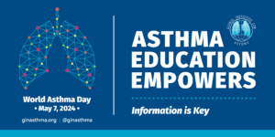
 | General post for the launch of the website – Version 1 | 📣 Exciting news! It’s #WorldAsthmaDay and aboutasthma.org is now translated into French, Italian and Spanish!  A 🆕 website for #patients and #caregivers with the latest science-based info & practical tips on #asthma.  Share #aboutasthma with your family and friends!  #asma #asthme
 | General post for the launch of the website – Version 2 | 📣 Did you hear the news? aboutasthma.org has arrived!  A brand new online resource 🆕 designed for #patients and #caregivers, packed with the latest #asthma science-based insights and tips.  Spread the word #AboutAsthma  #asma #asthme | 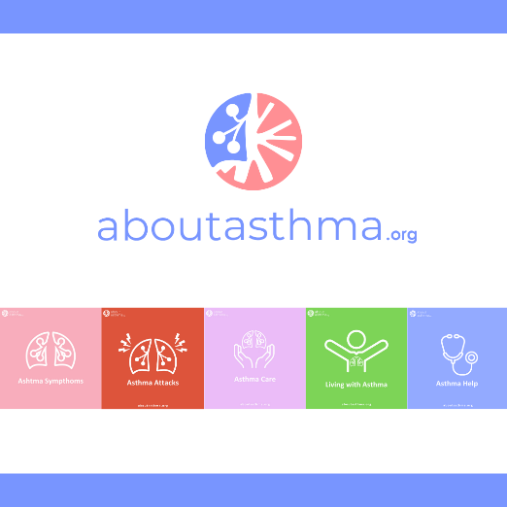
 | General post for the launch of the website – Version 3 | #Asthma doesn't have to hold you back.  A website for patients and caregivers with information and practical tips to 👇  🫸 prevent  🩺manage  🍀improve quality of life  Share aboutasthma.org with someone living with asthma and be a part of the solution! #AboutAsthma #WorldAsthmaDay
 | General post for the launch of the website – Version 4 | ❓🤔Do you need reliable tips on #asthma?  aboutasthma.org is packed with ⚛ science-based resources and support to anyone living with asthma.  Let’s breathe easier together. Share the link with your friends and family.  #AboutAsthma
 | Symptoms | ❓🤔 What does #asthma feel like?  Whether you’re a patient or a carer, in aboutasthma.org you can learn about:  🤷‍♀️Symptoms  ☑️Types of asthma  📈Risk factors  🧒Children with asthma  & more  Early recognition is vital. Share it with friends and family!  #AboutAsthma  #AsthmaSymptoms | 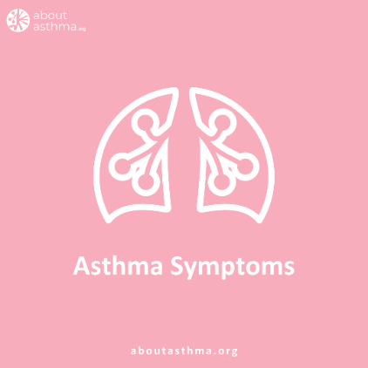
 | Attacks | 🚨 Feel equipped to handle an #AsthmaAttack?  Be ready to tackle it with aboutasthma.org.  Discover triggers, exacerbations and handling strategies.  #AboutAsthma | 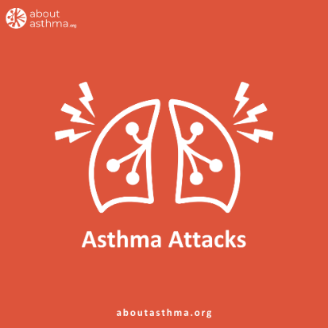
 | Care | 📋 Don't let managing #asthma feel overwhelming.  Explore aboutasthma.org for tips on prevention, control, symptom monitoring, consultations, and treatments.  Empower yourself and your loved ones today. Share with your friends and family!  #AboutAsthma | 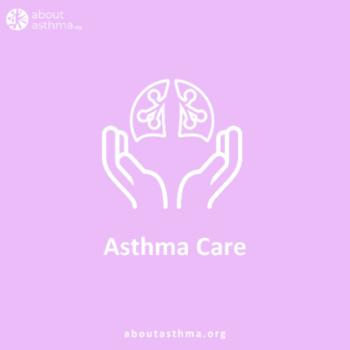
 | Life | 💪 Don't let #asthma hinder you or your loved ones.  Whether you're a patient or caregiver, aboutasthma.org has tailored tips for  - all age groups 👵 👫  -to confidently navigate challenges 😌  - to lead an active life 🏃.  #AboutAsthma | 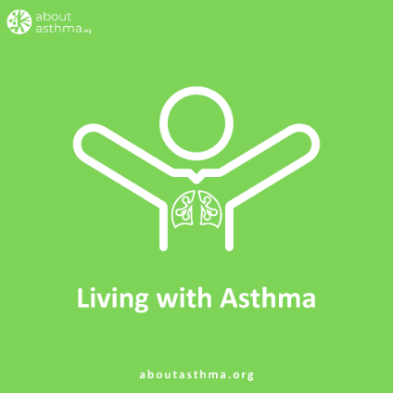
 | Help | 🤝 Ready to take control of #asthma with expert support?  Discover guidance for:  -Choosing the right healthcare professional  -First consultation  - Follow up care  - Ongoing management and effective control  Find out more 👉  aboutasthma.org  #AboutAsthma #AsthmaHelp #ProfessionalSupport | 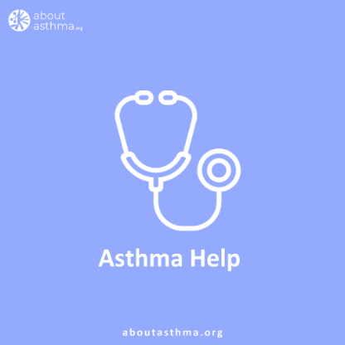
 | Teaser (Before May 6) | 📣 Exciting announcement incoming! 🌟  As we gear up for #WorldAsthmaDay on May 6, themed 'Asthma Education Empowers', we're thrilled to unveil that we’ve been working on an innovative online tool that aligns perfectly.  Think of science-based insights and reliable tips, available in several languages, aimed at empowering asthma patients and caregivers, helping them prevent, manage, and thrive with asthma.  Stay tuned for more updates! #AboutAsthma #asthma #patients #healthcareprofessionals
 | General post for the launch of the website | 🌍 Today marks #WorldAsthmaDay, themed ‘Asthma Education Empowers’, and we're excited to unveil the newly launched aboutasthma.org!  What sets aboutasthma.org apart? It's a science-backed resource, developed collaboratively with patients, packed with insights, practical tips, and actionable steps, covering five main areas of the condition:  🫁 Asthma Symptoms  ⚡️ Asthma Attacks  🤲 Asthma Care  🍀 Life with Asthma  🗣️ Asthma Help  Moreover, it's available in multiple languages, ensuring accessibility for a global audience.  From understanding symptoms to accessing care, this resource developed by the European Federation of Allergy and Airways Diseases Patients' Associations (EFA), empowers asthma patients and caregivers worldwide, providing them with reliable and easily understandable information.  Read the press release: (INSERT LINK TO PRESS RELEASE)  Join us in spreading the word! Visit aboutasthma.org today and share it with someone you know living with asthma.  #AboutAsthma #asthma #patients #healthcareprofessionals

Additional recommendations
We encourage you to craft more social media posts tailored to resonate with your audience and cater to local needs, spotlighting specific content from aboutasthma.org. We also advise to tag in the pictures your asthma partners at local level! Here are some ideas to spark your creativity:

Platform | Message | Post | Social media cards
 | Educational – Asthma attacks, what happens in the lungs? | 😖Do you know what happens in the lungs during an #AsthmaAttack?  Uncontrolled asthma may cause damage and reduce lung function.🌬 #Prevention is key.  Find out more 👉 aboutasthma.org, a website with info for patients and caregivers.  #AboutAsthma | 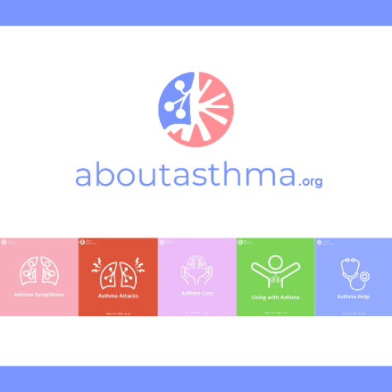
 | Asthma Attacks – how to help someone? | 🌪How to help someone with an #AsthmaAttack?  ☑Learn practical tips and actionable steps on aboutasthma.org, a website for patients and caregivers.  #AboutAsthma
 | Asthma treatments – Action Plan | Do you know that an asthma action plan 📓 is crucial to manage your asthma and improve control?  ✅Learn more on aboutasthma.org, a website for patients and caregivers.  #AboutAsthma
 | Caring for someone with Asthma – Children | 👧Is your child dealing with asthma? Feeling overwhelmed?  ❗Managing your child's asthma doesn’t have to be a burden.  ✅Discover simple steps to support your child on aboutasthma.org #AsthmaCare #ChildHealth

Website, Direct E-mail & / or Newsletter Announcement
Spread the word about aboutasthma.org by incorporating the customized message provided below into your newsletters, email campaigns, and/or website. Let your audience know about this invaluable resource and encourage their support!
aboutasthma.org, an innovative tool for asthma patients and caregivers
Did you know that over 30 million people in Europe, including a significant number of children, are living with asthma? Now, more than ever, there is a pressing need for easily accessible, accurate and comprehensive information online.
That’s why we're thrilled to introduce aboutasthma.org, a new intuitive website designed to empower patients living with asthma and their caregivers.
What distinguishes aboutasthma.org? It's a science-backed educational resource, co-created with patients, brimming with insights, practical tips and actionable steps. From decoding symptoms and handling attacks to accessing care and seeking professional support, aboutasthma.org, developed by the European Federation of Allergy and Airways Diseases Patients' Associations (EFA), delivers trustworthy and easily digestible information for everyone touched by asthma.
But wait, there’s more! It’s available in multiple languages, ensuring accessibility for individuals worldwide to access it in their preferred language (at the moment, in English, French, Italian, and Spanish).
Join us in spreading the word! Visit www.aboutasthma.org today and share it with someone you know living with asthma. Your support will not only help raise awareness about asthma but also empower individuals of all ages living with asthma, ultimately enhancing their quality of life.

Additional Recommendations to support aboutasthma.org

aboutasthma.org offers a wealth of comprehensive information that can be customized to fit various formats and cater to different audiences. Here's how you can tailor the content to make a meaningful impact in your national community:
- Customise educational materials: Adapt factsheets, infographics, and videos to align with your local context and target demographic. This could involve creating factsheets specifically for parents or teenagers, or educational content about available treatments and short videos covering various aspects of asthma management (symptoms, attacks, care, life, and seeking help), directing viewers to the website for more details.
- Design promotional materials: Create eye-catching posters and flyers prominently displaying the website URL. Distribute these materials at events / conferences, workshops, and healthcare facilities, frequently accessed by patients, such as doctors' and nurses' offices, clinics, hospitals, etc. This strategy effectively promotes awareness and accessibility within the community.
- Engage with local media: Connect with local newspapers and specialized community newsletters to share the launch of aboutasthma.org and its significance for the local community. By collaborating with the media, you can amplify the message and reach a broader audience, fostering greater awareness and support for asthma patients and carers.
As members of EFA Patients’ community, we have a shared responsibility to support and empower each other, especially when it comes to managing health conditions like asthma. That's why we're excited to introduce this toolkit, designed to equip with resources needed to make a positive impact within asthma communities worldwide.
You can use this toolkit and tailor it to fit the specific needs for asthma in your country.

AboutAsthma.org
Thank you for your support!
¡Gracias por tu apoyo!
Merci pour votre soutien !
Grazie per il vostro sostegno!

“Active Asthma and COPD Patients ACCESS Care Report”, 2019 https://www.efanet.org/images/Active_Patients_ACCESS_Care___EFA_Report_2019.pdf

